Cointegration and ECM: EURUSD and EURGBP
Method 27 / Engle-Granger on log closes / one-lag ECM / Alpari D1 full available history

Study setup
Logical pair: PX=EURUSD , PY=EURGBP
Broker symbols: EURUSD_i , EURGBP_i
Snapshot: 2026-11-03_majors_alpari_D1
Timeframe: D1
Matched window: 1999-01-06 to 2026-11-02 (UTC bar dates)
Matched level count n: 7183
Dropped unfinished last bar dated 2026-11-03 UTC after a tick-volume check against the prior complete day.
ECM lags of deltas: 1
Complete matched rows (Excel): EURUSD-EURGBP_Coint_D1.xlsx
Complete matched rows (HTML table): EURUSD-EURGBP_Coint_D1_data.html

Method carried forward
Engle-Granger cointegration works on log price levels, not returns. For each unordered pair, PX is the left leg and PY the right leg. Step one: OLS ln(PY) = alpha + beta * ln(PX) + e. Step two: statsmodels Engle-Granger coint test on (ln(PY), ln(PX)). Error-correction: delta ln(PY)_t = c + kappa * e_{t-1} + lagged delta ln(PY) and delta ln(PX) (one lag each) + u_t. Headline is the Engle-Granger p-value (lower = stronger evidence of a stationary spread) with kappa and beta reported alongside. Same-sample Pearson r of log returns is a side check only. beta is not an automatic lot-size hedge. This is not a trading signal.

Results (headline)
alpha: -0.310483
beta: 0.397265
Engle-Granger t: -1.411177
Engle-Granger p: 0.793656
5% critical value: -3.336981
ECM kappa: -0.000710
kappa t-stat: -1.4504
ECM R^2: 0.001961
spread std: 0.117374
Pearson r (returns): 0.439899

Conclusion
Engle-Granger for PY=EURGBP on PX=EURUSD: beta=0.3973, alpha=-0.3105, coint_t=-1.4112, p=0.7937 (5% crit=-3.3370). ECM kappa=-0.0007 (t=-1.45). Pearson r of returns = 0.4399. beta is not a lot-size hedge. Not a trading signal.

Charts
Daily closes

Engle-Granger residual spread
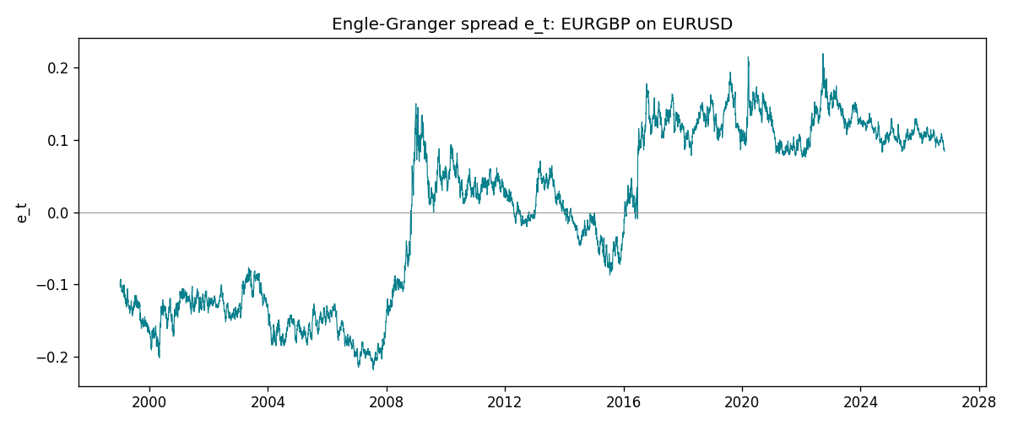
Daily log returns
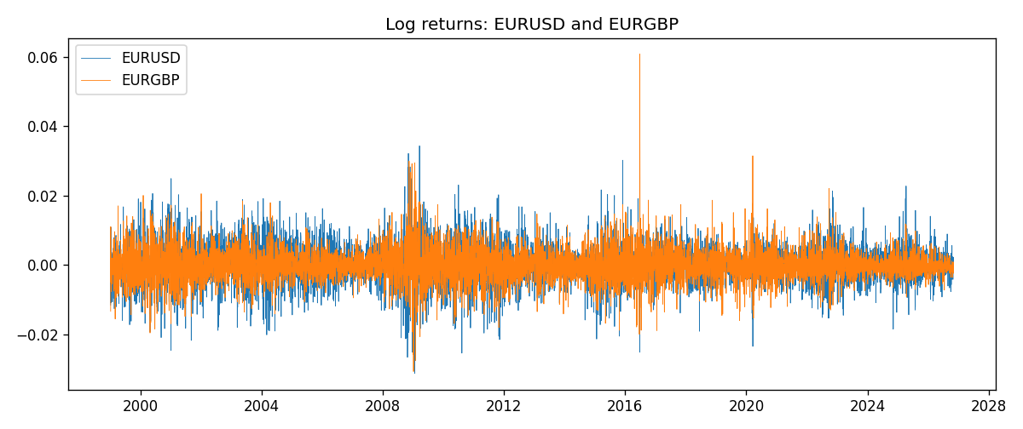

Data report
Matched rows are in the sibling Excel workbook named EURUSD-EURGBP_Coint_D1.xlsx. Embedding all rows as a Word table is impractical; this file holds column summaries and the first and last 15 matched rows.
Column summaries
column | count | mean | std | min | 25% | 50% | 75% | max
EURUSD_open | 7183 | 1.1815763 | 0.15079461 | 0.8272 | 1.08621 | 1.16623 | 1.29409 | 1.5995
EURGBP_open | 7183 | 0.78698868 | 0.09663692 | 0.5734 | 0.6877 | 0.83389 | 0.86522 | 0.9769
EURUSD_high | 7183 | 1.1867072 | 0.15139096 | 0.8326 | 1.09029 | 1.17134 | 1.29941 | 1.6038
EURGBP_high | 7183 | 0.79006638 | 0.09701205 | 0.5789 | 0.6897 | 0.8369 | 0.8681 | 0.9799
EURUSD_low | 7183 | 1.1765677 | 0.15011491 | 0.8227 | 1.08209 | 1.16259 | 1.288515 | 1.5865
EURGBP_low | 7183 | 0.78428899 | 0.09645396 | 0.5682 | 0.6857 | 0.83166 | 0.86287 | 0.9661
EURUSD_close | 7183 | 1.1816163 | 0.15076829 | 0.8267 | 1.086135 | 1.16619 | 1.2941 | 1.5997
EURGBP_close | 7183 | 0.78703222 | 0.09663758 | 0.5735 | 0.6878 | 0.83395 | 0.86536 | 0.977
EURUSD_tick_volume | 7183 | 103246.15 | 173560.03 | 218 | 9420.5 | 52790 | 99596.5 | 1471626
EURGBP_tick_volume | 7183 | 87133.93 | 145499.42 | 154 | 6594.5 | 44358 | 81413 | 1424684
EURUSD_spread | 7183 | 19.326744 | 16.542159 | 0 | 8 | 12 | 20 | 50
EURGBP_spread | 7183 | 21.324655 | 19.119277 | 0 | 4 | 13 | 40 | 50
EURUSD_real_volume | 7183 | 4.0347326e+10 | 1.669497e+11 | 0 | 0 | 0 | 0 | 3.6149665e+12
EURGBP_real_volume | 7183 | 2.7872287e+10 | 1.3521454e+11 | 0 | 0 | 0 | 0 | 3.5726265e+12
EURUSD_log_price | 7183 | 0.15864615 | 0.12897817 | -0.19031341 | 0.08262552 | 0.15374202 | 0.25781547 | 0.46981611
EURGBP_log_price | 7183 | -0.2474585 | 0.12807078 | -0.55599734 | -0.37425718 | -0.18158183 | -0.14460967 | -0.02326863
EURUSD_log_return | 7183 | -5.81e-06 | 0.0057996 | -0.03123819 | -0.00324487 | 0 | 0.00325442 | 0.03433183
EURGBP_log_return | 7183 | 2.227e-05 | 0.00487305 | -0.03067367 | -0.00262314 | -9.879e-05 | 0.00256076 | 0.06075387
spread_e | 7183 | -0 | 0.11737433 | -0.21844337 | -0.12496664 | 0.0247724 | 0.10849597 | 0.21972328
ecm_fitted | 7182 | 2.412e-05 | 0.0002157 | -0.00113988 | -0.00010704 | 2.246e-05 | 0.0001511 | 0.00254956
First 15 matched rows (selected columns)
time | EURUSD_log_price | EURGBP_log_price | spread_e | EURUSD_log_return | EURGBP_log_return
1999-01-06 | 0.1504008 | -0.35396434 | -0.10323024 | -0.011547966 | -0.013303338
1999-01-07 | 0.15802886 | -0.34291293 | -0.095209207 | 0.0076280636 | 0.011051402
1999-01-08 | 0.14712606 | -0.3478568 | -0.095821764 | -0.010902799 | -0.004943862
1999-01-11 | 0.14002278 | -0.34913203 | -0.094275113 | -0.007103287 | -0.0012752393
1999-01-12 | 0.14453315 | -0.345735 | -0.092669897 | 0.0045103728 | 0.0033970309
1999-01-13 | 0.1553785 | -0.34531119 | -0.09655456 | 0.010845346 | 0.00042381861
1999-01-14 | 0.1553785 | -0.34729054 | -0.098533919 | 0 | -0.0019793588
1999-01-15 | 0.14522525 | -0.35496213 | -0.10217197 | -0.010153245 | -0.0076715819
1999-01-18 | 0.14885095 | -0.35424932 | -0.10289952 | 0.0036256946 | 0.00071280921
1999-01-19 | 0.14867859 | -0.35567544 | -0.10425718 | -0.00017235436 | -0.0014261269
1999-01-20 | 0.14548467 | -0.35367943 | -0.10099233 | -0.0031939256 | 0.0019960086
1999-01-21 | 0.14850621 | -0.35439184 | -0.10290509 | 0.0030215416 | -0.00071240297
1999-01-22 | 0.14729869 | -0.35610368 | -0.10413722 | -0.0012075213 | -0.0017118406
1999-01-25 | 0.14427349 | -0.36154392 | -0.10837566 | -0.0030251979 | -0.0054402425
1999-01-26 | 0.14513877 | -0.3621183 | -0.10929379 | 0.00086527651 | -0.00057438255
Last 15 matched rows (selected columns)
time | EURUSD_log_price | EURGBP_log_price | spread_e | EURUSD_log_return | EURGBP_log_return
2026-10-13 | 0.11301614 | -0.16891582 | 0.09666991 | 0.0037402957 | 0.00020130374
2026-10-14 | 0.10925791 | -0.16779163 | 0.09928711 | -0.0037582255 | 0.0011241873
2026-10-15 | 0.11486322 | -0.1686672 | 0.09618474 | 0.0056053107 | -0.00087557391
2026-10-16 | 0.11663571 | -0.17070529 | 0.093442507 | 0.0017724895 | -0.0020380844
2026-10-19 | 0.11409625 | -0.1712748 | 0.093881838 | -0.0025394633 | -0.00056950988
2026-10-20 | 0.11648442 | -0.17486542 | 0.089342476 | 0.0023881672 | -0.0035906254
2026-10-21 | 0.11616395 | -0.17627189 | 0.088063317 | -0.00032046717 | -0.00140647
2026-10-22 | 0.11456899 | -0.17814629 | 0.086822547 | -0.0015949606 | -0.0018743924
2026-10-23 | 0.11323047 | -0.17732208 | 0.088178505 | -0.001338521 | 0.00082421033
2026-10-26 | 0.11095981 | -0.17719074 | 0.089211891 | -0.0022706559 | 0.00013133309
2026-10-27 | 0.10680747 | -0.17918648 | 0.088865739 | -0.004152342 | -0.0019957343
2026-10-28 | 0.10903376 | -0.1785168 | 0.088650982 | 0.0022262927 | 0.00066967224
2026-10-29 | 0.1112909 | -0.17968902 | 0.08658208 | 0.0022571351 | -0.0011722209
2026-10-30 | 0.11014505 | -0.18210958 | 0.08461673 | -0.0011458446 | -0.0024205543
2026-11-02 | 0.11226562 | -0.18121017 | 0.084673706 | 0.002120569 | 0.00089940465

